Orbits of the Planets
Think the orbits of the planets are cigar shaped ellipses? Think again.

Materials Needed (for every student)
• push pins
• thread or thin string
• butcher paper (or other large sheet)
• ruler
• pencil or pen
• Styrofoam board or thick cardboard

Background
What is an ellipse? An ellipse is a curve for which the sum of the distances from any point along the curve to each foci inside the ellipse are always equal. Figure 1 below shows the geometry of an ellipse. Note that ellipses have two foci, a semi-major axis (a), and a major axis (2a). The eccentricity (e) of an ellipse is the ratio of the distance between the two foci and the length of the major axis.
e = (Distance between the foci) ÷ (Length of the major axis)
We will use this information to investigate the eccentricity (e) of orbits of objects in our solar system.

Figure 1

What To Do
• Pick one of the planets or comets listed in Table 1. Note that the table lists dimensions in astronomical units. One astronomical unit equals the average distance between the earth and the sun. If you try to draw your ellipse to scale, you will have a problem finding enough paper. So, you should choose a scale so that you can easily fit your ellipse on a piece of butcher paper. You can try 10 cm = 1 A.U. for the inner planets (Mercury to Mars). For the outer planets and the comets (Jupiter to Pluto) you might want to try 1 cm = 1 A.U.

• Place a sheet of butcher paper on the Styrofoam board. Using the information supplied below for your planet/comet and the scaling factor you chose, place pins a distance of 2ae apart and cut a length of string equal to 2a + 2ae.

• Put the loop around the pins. Using a pencil as shown in Figure 2, sketch out the shape of the orbit.
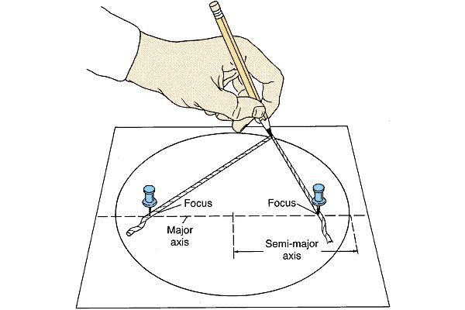Figure 2

• Compare the orbit of your planet/comet to the other orbits drawn by pother members of the class. How elliptical is your orbit? Is it cigar shaped? An oval? Or is your orbit nearly circular? Are you surprised?

What’s Going On?
Because of misleading diagrams often seen in books other astronomy reference materials, most people believe that the orbits of the planets are highly elliptical – almost cigar shaped. In fact, the orbits of the planets are very nearly circular.

The problem with this misconception about planetary orbits is that it leads many students to erroneously believe that the cause of the earth’s seasons has something to do with changing distance to the sun. After all, if the earth’s orbit were as elliptical as these students believe, we would in fact be much closer to the sun during certain times of the year and much further away at other times.

The fact is that the earth’s orbit is very close to being circular. At our closest approach to the sun, we are 147,000,000 kilometers away. At farthest approach to the sun, we are 152,000,000 kilometers away. Our distance from the sun varies by only 3% – not enough to account for changes in how the earth is heated by the sun during the year.

Table 1: Orbital dimensions of some objects in our solar system

Name of  Body | e  (eccentricity) | a  (A.U.) | 2ae = dist between foci  (A.U.) | 2a+2ae = string length (A.U.)
Mercury  Venus  Earth  Mars  Asteroid  Apollo  Asteroid  Eros  Jupiter  Saturn  Uranus  Neptune  Halley’s Comet  Pluto | 0.200  0.001  0.017  0.093  0.56  0.22  0.048  0.056  0.047  0.008  0.97  0.250 | 0.38  0.72  1.00  1.52  1.47  1.46  5.20  9.54  19.18  30.06  17.90  39.44 | 0.150  0.001  0.034  0.283  1.65  0.64  0.499  1.068  1.803  0.481  34.73  19.72 | 0.91  1.44  2.03  3.32  4.59  3.56  10.90  20.15  40.16  60.60  70.53  98.60

